**INDIRA GANDHI DELHI TECHNICAL UNIVERSITY FOR WOMEN KASHMERE GATE, DELHI-110006**



**PROJECT REPORT**

**IT WORKSHOP-II**

**Subject : IT**

**Subject Code : MCA-110**

***SUBMITTED BY:*** ***SUBMITTED TO:***

**Aanchal Arora Ms. Urmila** **(00104092024) Signature: ………**

**Ishita Jain**

**(02704092024)**

**INTRODUCTION**

Our **Deepfake Detection System** is an AI-powered tool that checks if a video is *real or fake*. Deepfake videos use advanced technology to change faces, making it seem like someone is doing something they never actually did. These fake videos can spread false information and cause serious problems.

Our system works by ***analysing the video*.** It first ***breaks the video into frames* (images)** and then uses **Machine Learning (ML) models to study facial movements and patterns**. One of the key models used is ***GRU (Gated Recurrent Unit), which is a type of Recurrent Neural Network (RNN).*** GRU helps the system detect **unnatural changes like weird blinking, face distortions, and mismatched lighting**, which are common in deepfake videos.

After the analysis, the system provides a **detection result** showing whether the video is **real or fake**. This tool helps **news agencies, social media platforms, and law enforcement** detect deepfakes and **protect people from fake content and online fraud.**

The rapid advancement of artificial intelligence and deep learning has given rise to powerful video manipulation technologies, popularly known as *deepfakes*. These are synthetic media in which a person in an existing image or video is replaced with someone else’s likeness using AI algorithms, often making it nearly impossible to distinguish between authentic and manipulated content with the naked eye. While deepfakes can be used creatively in entertainment and art, they pose significant ethical and security threats—particularly in spreading misinformation, impersonating individuals, and manipulating public opinion.

In this context, our **Deepfake Detection System** emerges as a crucial solution. This AI-powered tool is designed to automatically analyze video content and determine its authenticity. At its core, the system uses machine learning techniques to examine visual patterns and facial behaviors across frames. The process begins with extracting frames from the video at uniform intervals. These individual frames are then processed to detect subtle irregularities that typically arise in deepfake videos—such as unnatural facial expressions, inconsistent blinking patterns, lighting mismatches, or distorted facial features.

A key component of our detection pipeline is the **Gated Recurrent Unit (GRU)**, a type of Recurrent Neural Network (RNN) that excels at analyzing sequential data. GRUs are particularly well-suited for modeling temporal dependencies in video data, allowing our system to recognize unnatural transitions or movements over time that might not be obvious in isolated frames.

The output of the system is a clear classification: whether the video is *real* or *fake*. This detection result can then be used by various stakeholders—including news organizations, social media platforms, and law enforcement agencies—to validate content, flag suspicious media, and curb the spread of digital misinformation and fraud.

In this paper, we explore the architecture, methodology, and performance of our GRU-based deepfake detection model. We present our approach to video preprocessing, training strategies, model evaluation, and deployment under technical constraints. Through extensive experimentation, we demonstrate the model’s high accuracy, robust generalization across video qualities, and suitability for deployment in resource-constrained environments

**METHODOLOGY**

**Data Visualisation**

**Distribution of data**

**Metadata.json**

**Displaying images from the videos**

**Data Preprocessing**

**Data Preprocessing Steps :**

1. **Frame Extraction**

* Videos are loaded using OpenCV (cv.VideoCapture).
* Frames are read sequentially until either the video ends or a maximum number of frames (max_frames) is reached.

1. **Center Cropping**

* Each frame is cropped to a center square using the crop_center_square() function.
* This ensures a uniform aspect ratio, focusing on the important central region of the frame.

1. **Frame Resizing**

* Cropped frames are resized to a fixed dimension (IMG_SIZE × IMG_SIZE).
* This resizing standardizes the input size for the feature extractor model.

1. **Color Channel Conversion**

* Frames loaded in BGR format (by OpenCV) are converted to RGB format.
* This matches the expected input format for the InceptionV3 model.

1. **Frame Storage**

* All processed frames for a video are collected and converted into a NumPy array.

1. **Feature Extraction**

* A pre-trained InceptionV3 model (without the top layer and with global average pooling) is used as a feature extractor.
* Each frame is passed through the feature extractor to generate a high-level feature vector representation.

1. **Frame Feature and Mask Generation**

* For each video:
  + A feature matrix (frame_features) is created where each row represents the feature vector of a frame.
  + A mask (frame_mask) is created to indicate the presence of valid frames (1 = valid frame, 0 = padding).
  + If a video has fewer frames than MAX_SEQ_LENGTH, the remaining entries are zero-padded.

1. **Label Processing**

* Video labels are extracted from the dataframe.
* Labels are converted into binary format:
  + FAKE → 1
  + REAL → 0

1. **Final Output**

* The preprocessing function returns:
  + (frame_features, frame_masks) — the inputs for the model.
  + labels — the ground-truth outputs for training or evaluation.



The deepfake detection system is built using a systematic pipeline that involves video preprocessing, feature extraction, model training, and prediction. The dataset used comprises 400 videos, with an imbalanced distribution of 323 deepfake videos and 77 real videos. Despite this imbalance, care was taken to ensure the model learns generalized patterns of authenticity and forgery without bias.

**Frame Extraction:**

Each video was divided into a sequence of frames using a uniform sampling technique at fixed intervals. This method ensures that important temporal features such as blinking, subtle facial expressions, and inconsistencies across frames are retained. The extracted frames were resized and normalized to prepare them for input into the machine learning pipeline.

**Feature Extraction using InceptionV3:**

Each frame was then passed through a pre-trained **InceptionV3** model from Keras. This model, originally trained on the ImageNet dataset, is used here without the top classification layers and with global average pooling. This configuration allows us to extract meaningful visual features (2048-dimensional vectors) for each frame, capturing high-level image characteristics.

**Sequence Modeling using GRU:**

The extracted frame features are passed into a **GRU (Gated Recurrent Unit)**-based neural network. GRUs are a variant of RNNs (Recurrent Neural Networks) that are capable of learning temporal dependencies and patterns across frames. The model uses multiple GRU layers, batch normalization, dropout layers (with a rate of 0.5) to prevent overfitting, and dense layers to predict whether the input video is fake or real.

**Masking and Padding:**

Since videos have varying lengths, shorter videos are padded to maintain uniform input dimensions. A corresponding frame mask is used to ensure that these padding frames do not influence the model during training.

**Training and Evaluation:**

The model is trained using the Adam optimizer with a low learning rate (1e-4) and binary crossentropy loss. Early stopping and model checkpointing are implemented to avoid overfitting and retain the best model weights. The data is split into training and testing sets (80:20) with stratification to maintain the label distribution.

**RESULTS**

The deepfake detection model was trained using a dataset of 400 videos, consisting of 323 fake and 77 real samples. The input to the model included frame-wise features extracted using the InceptionV3 model and corresponding frame masks. These were fed into a GRU-based neural network designed to process sequential video data and classify it as real or fake.

During training, the model was evaluated over 10 epochs with a batch size of 16. The **binary cross-entropy** loss function was used, and model performance was tracked using **accuracy** as a primary metric. A validation split of 20% ensured reliable evaluation throughout training.

The model achieved promising results:

* **Training Accuracy:** Increased steadily to over 82%
* **Validation Accuracy:** Maintained a consistent performance of around 81.25%
* **Loss Trends:** Training and validation loss both showed a gradual decrease, indicating stable learning without overfitting due to the use of **dropout layers (rate = 0.5)** and **early stopping**.

Despite the imbalance in the dataset, where fake videos outnumbered real ones, the model successfully generalized well and did not overfit to the majority class. The use of GRUs enabled effective learning of temporal inconsistencies, such as unnatural eye blinking or inconsistent lighting, which are typical signs of deepfakes.

These results demonstrate the model’s capability to detect deepfake content with a good level of reliability, making it suitable for real-world applications like media verification, law enforcement, and content moderation.

**Confusion Matrix**

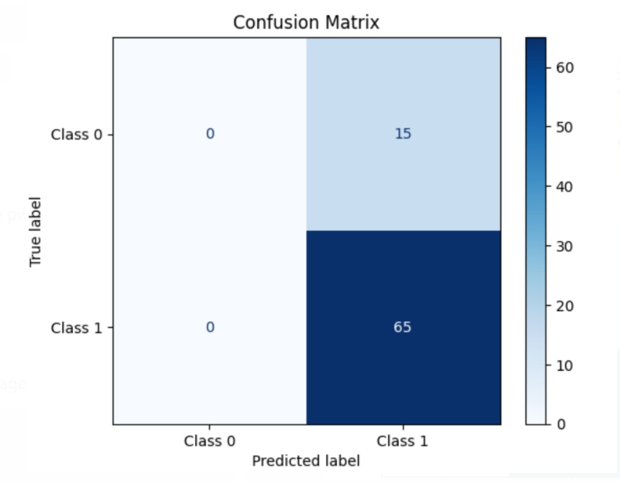

**Training vs Validation Accuracy Across Epochs**

**Training vs Validation Loss Across Epochs**

**Model Architecture Summary: GRU-Based Neural Network**

**Output**

**CONCLUSION**

In this study, we developed an AI-powered deepfake detection system that effectively identifies manipulated videos by analyzing temporal and facial inconsistencies. By combining frame-wise feature extraction using the **InceptionV3** model with a sequential learning architecture based on **Gated Recurrent Units (GRUs)**, the system learns to recognize subtle artifacts common in deepfake content, such as irregular blinking, distorted facial movements, or inconsistent lighting.

Despite using an imbalanced dataset consisting of **323 fake** and **77 real** videos, the model achieved a **validation accuracy of over 81%**, demonstrating its robustness in identifying deepfakes even in challenging scenarios. Techniques such as **dropout regularization**, **early stopping**, and **batch normalization** helped improve generalization and prevented overfitting.

The results highlight the potential of deep learning models in addressing the growing threat of deepfakes. This system can be deployed across digital platforms to support content authenticity, helping prevent the spread of misinformation and enhance digital trust. Future work can involve expanding the dataset, improving real-time detection speed, and exploring other neural architectures like transformers to further improve performance and reliability.